CONTINUOUS INTERNAL ASSESMENT 1

MN KASHIFKHAN

727721EUIT072

**QUESTION 1:**

**CODING:**

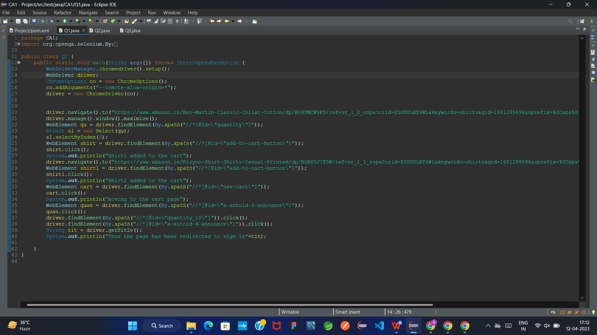

**OUTPUT:**

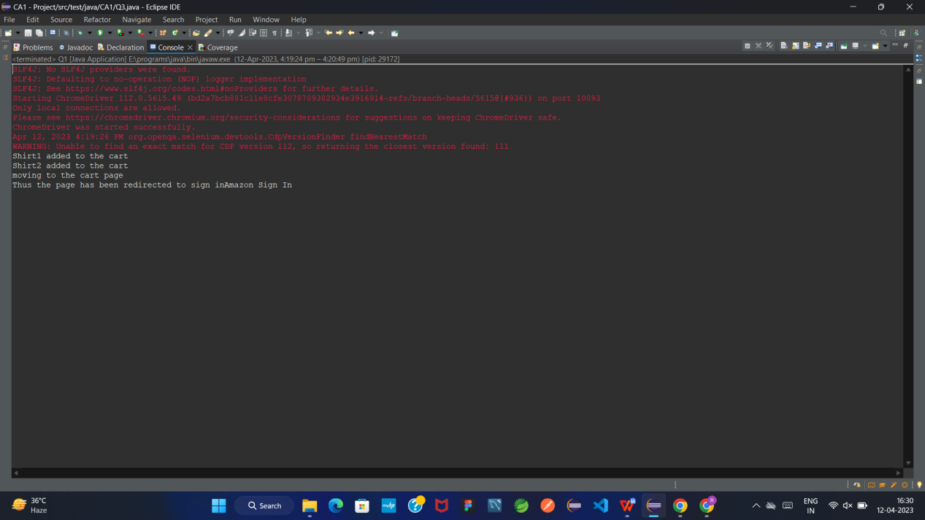

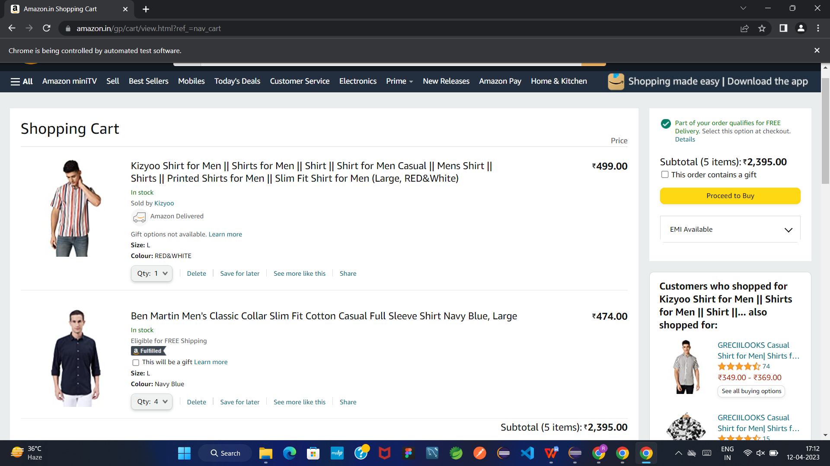

**QUESTION 2:**

**CODING:**

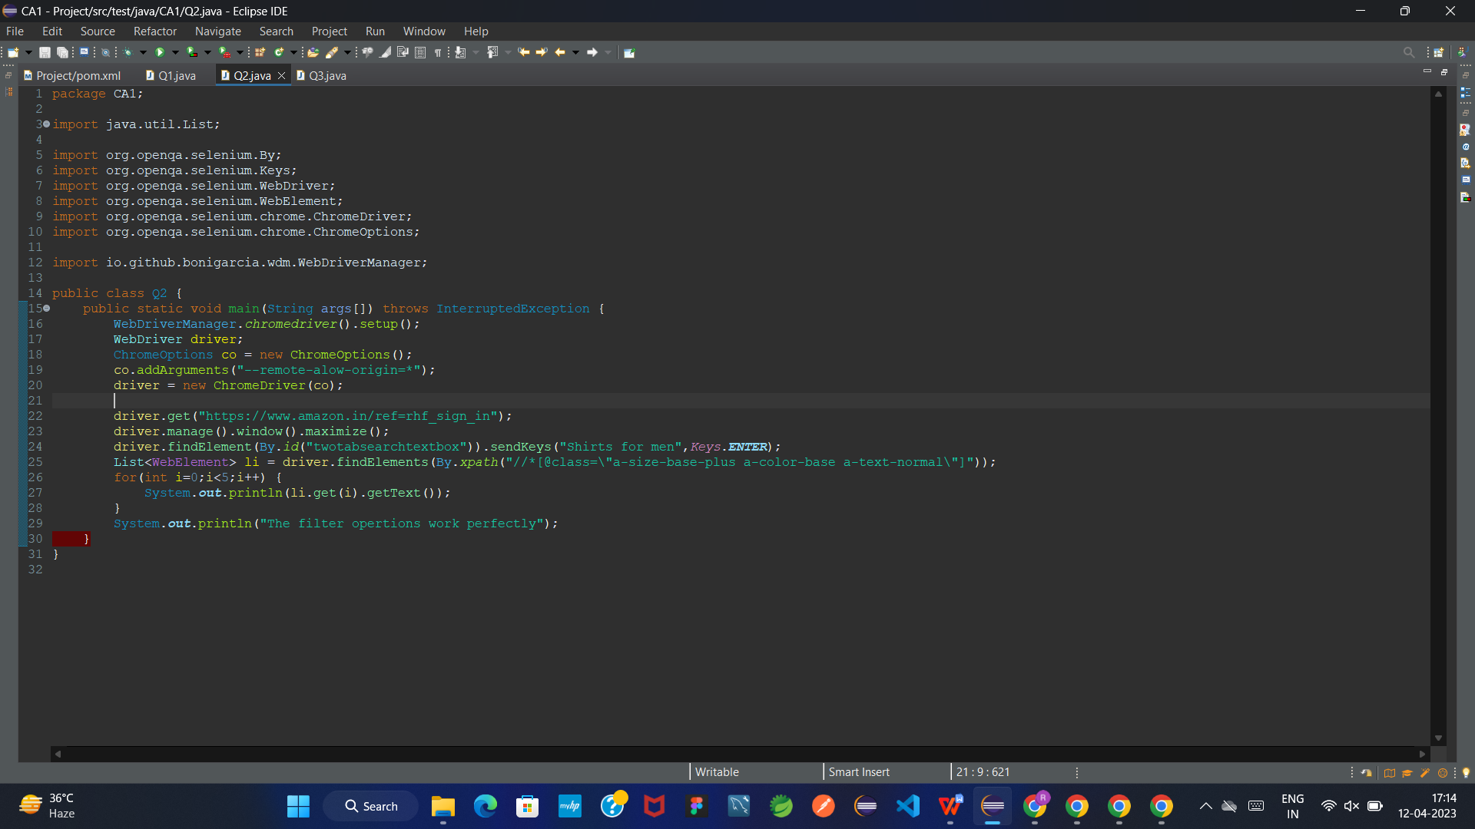

**OUTPUT:**



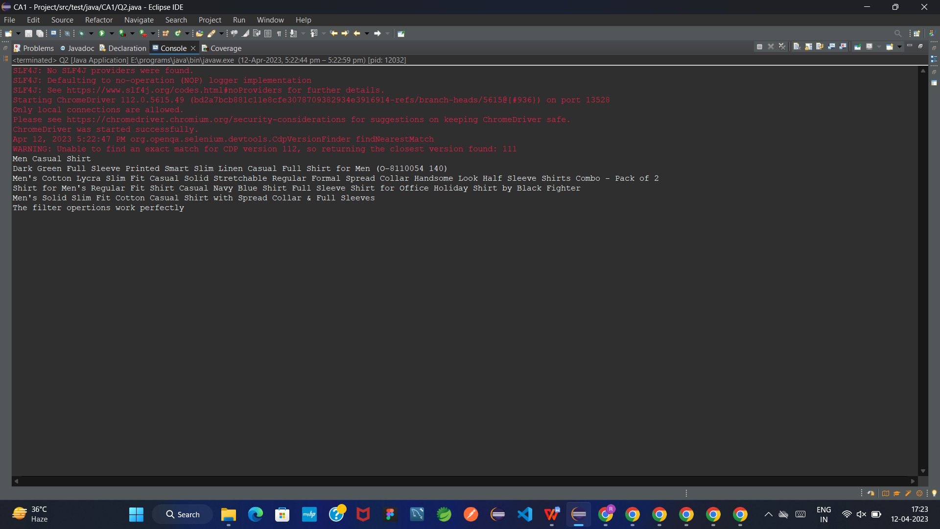

**QUESTION 3:**

**CODING:**

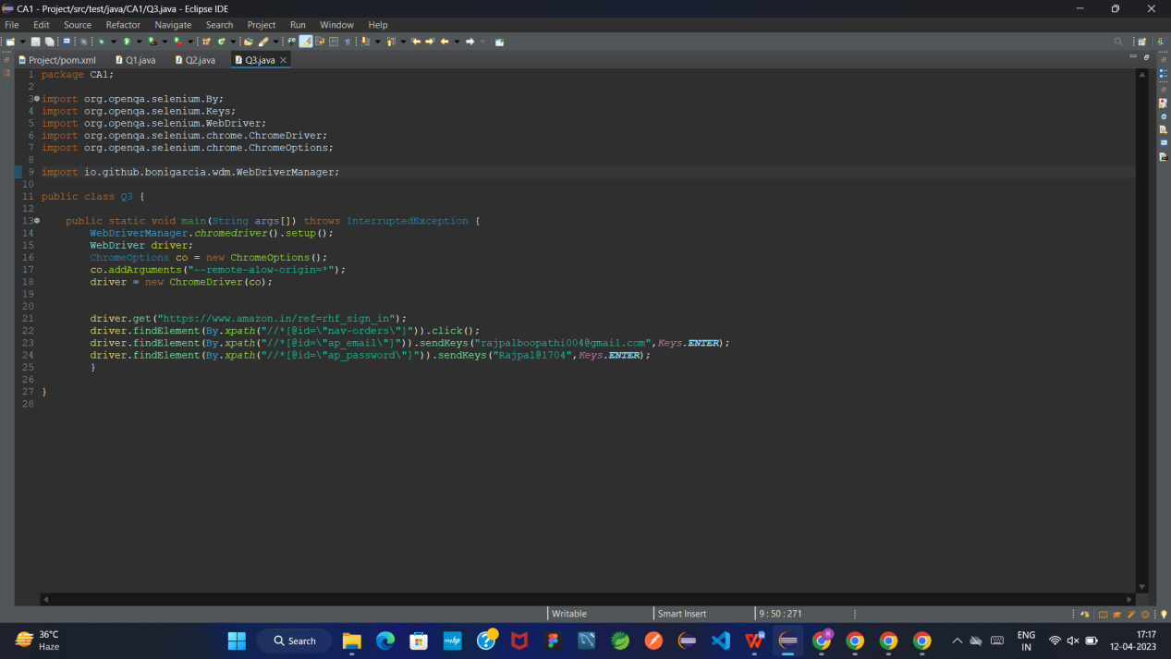

**OUTPUT:**

